**Spring 2021-2022**

**METU, Department of Economics**

**Instructor:** Dr. Yelda Erden Topal

**S.A.:** Ali Erdem Yurtseven

**S.A.:** Aybüke Kayapınar

**ECON 212 – Principles of Economics II**

**Problem Set 2**

**LONG QUESTIONS:**

**1) What is the paradox of thrift?**

The paradox of thrift, often known as the savings paradox, is an economic hypothesis that claims personal savings are a net drag on the economy during a downturn.

**2) Explain why the short-run aggregate supply (SAS) curve is upward sloping and why the long-run aggregate supply (LAS) curve is vertical**.

Sellers of finished goods receive greater pricing for their products in the short run, but the cost of their inputs does not rise in lockstep. The higher the price, the more willing these suppliers are to supply. As a result, the SAS curve is upward sloping, demonstrating the short-run positive association between price level and quantity of items supplied.

**3) Demonstrate graphically and explain verbally the role the multiplier effect has in the shape of the aggregate demand curve.**

The multiplier impact refers to any changes in consumer spending that occur as a result of fiscal policy-induced real GDP growth or contraction.

**4) Demonstrate graphically and explain verbally a recessionary gap. Describe two solutions for closing the gap.**

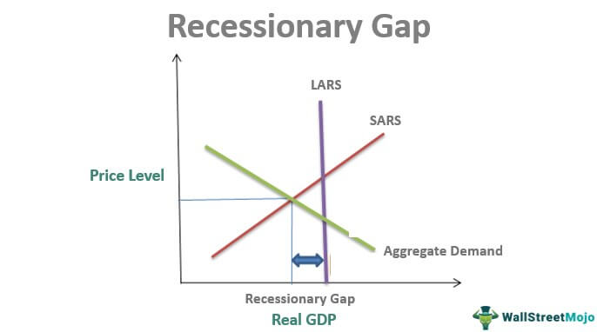Recessionary gap occurs when a country’s real GDP is lower than its GDP at full employment.

The government can cut the tax rates and increase spending to close the gap.

**5) Demonstrate graphically and explain verbally the case of an inflationary gap. Describe the forces in the economy that will result in the gap closing itself.**

The difference between the current level of real GDP and the GDP that would exist if an economy were fully employed is known as the inflationary gap.  Reductions in government spending, tax increases, bond and securities issues, interest rate increases, and transfer payment reductions can help to close this gap.

**MULTIPLE CHOICE QUESTIONS:**

**1)** The aggregate expenditure model focuses on the relationship between ________ and ________ in the short run, assuming ________ is constant.

A) total income; real GDP; the price level

B) total production; total income; real GDP

C) total spending; real GDP; the price level

D) total spending; real GDP; total income

**2)** An unplanned increase in inventories results from

A) actual investment that is less than planned investment.

B) a decrease in planned investment.

C) actual investment that is greater than planned investment.

D) an increase in planned investment.

**3)** Consumption spending is $12 million, planned investment spending is $14 million, unplanned investment spending is $4 million, government purchases are $18 million, and net export spending is $4 million. Calculate the GDP.

A) $34 million

B) $44 million

C) $48 million

D) $52 million

**4)** Which of the following will cause a direct increase in consumption spending?

A) an increase in government spending

B) an increase in disposable income

C) an increase in planned investment

D) a decrease in net export spending

**5)** An increase in the real interest rate will

A) most likely lower the cost of borrowing.

B) most likely lower consumers' purchases of durable goods.

C) most likely lower the reward to savings.

D) cause consumers to spend more and save less.

**6)** If the MPC is 0.5, then a $10 million increase in disposable income will increase consumption by

A) $5 million

B) $10 million.

C) $15 million.

D) $20 million.

**7)** If the marginal propensity to save is 0.35, then a $20,000 decrease in disposable income will

A) increase consumption by $13,000.

B) decrease consumption by $13,000.

C) decrease consumption by $7,000.

D) increase consumption by $7,000.

**8)** Investment spending ________ during a recession, and ________ during an expansion.

A) increases; declines

B) declines; declines

C) declines; increases

D) increases; increases

**9)** If firms are more optimistic that future profits will rise and remain strong for the next few years, then

A) investment spending will remain unaffected.

B) investment spending will fall.

C) investment spending will rise.

D) investment spending will rise and then fall.

**10)** ________ usually increase(s) when the Turkish economy is in a recession and decrease(s) when the Turkish economy is expanding.

A) Net Exports

B) Consumer spending

C) Unplanned investment

D) Planned investment

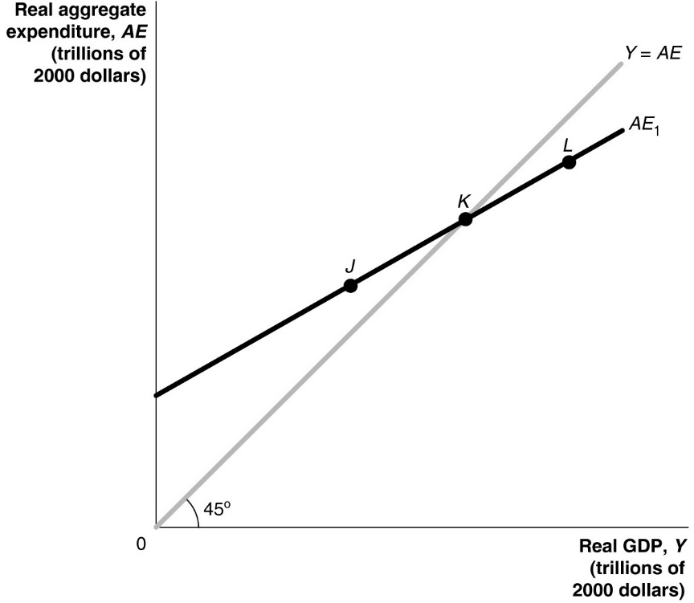

**11)** Refer to figure above. According to the figure above, at what point is aggregate expenditure greater than GDP?

A) J

B) K

C) L

D) none of the above

**12)** Refer to figure above. At point L in the figure above, which of the following is true?

A) GDP will be increasing.

B) Aggregate expenditure is greater than GDP.

C) Actual inventories are greater than planned inventories.

D) The economy has achieved macroeconomic equilibrium.

**13)** Refer to figure above. If the economy is at point L, what will happen?

A) Inventories have fallen below their desired level, and firms increase production.

B) Inventories have risen above their desired level, and firms increase production.

C) Inventories have risen above their desired level, and firms decrease production.

D) Inventories have fallen below their desired level, and firms decrease production.

**14)** Refer to figure above. If the economy is at a level of aggregate expenditure given by point K,

A) production is less than spending.

B) production is greater than spending.

C) inventories will increase above their desired level.

D) the economy is in equilibrium.